**OBJECTIVES:**

* To determine the quiescent operating conditions of the fixed-bias BJT configuration.

**EQUIPMENT:**

* Digital Multimeter (DMM)
* DC Power Supply

**COMPONENTS**

* Resistors: :680 kΩ ,10 kΩ 2.2 kΩ ,33 kΩ
* Transistors: 2N3904, 2N4401

**THEORY:**

**Biasing of the bipolar junction transistor (BJT)** is the process of applying external voltages to it. In order to use the BJT for any application like amplification, the two junctions of the transistor CB and BE should be properly biased according to the required application. Depending on whether the two junctions of the transistor are forward or reverse biased, a transistor is capable of operating in three different modes.

**Cutoff Mode of BJT:**

The BJT is fully off in this state. In the cutoff mode both the base emitter as well as collector base junction is reverse biased. The BJT is equivalent to an open switch in this mode.

**Saturation Mode of BJT:**

The transistor is fully on in this state. The CB as well as BE junctions are forward biased. The BJT operates like a closed switch in the saturation mode. If a BJT is in saturation mode than it should satisfy the following condition



Where, βDC is common emitter current amplification factor or current gain.

**Active Mode of BJT:**

In order to use the transistor as an amplifier, it must be operated in the active mode. The BE junction is forward biased whereas the CB junction is reverse biased. Figure below shows both n-p-n and p-n-p transistors biased in the active mode of operation.

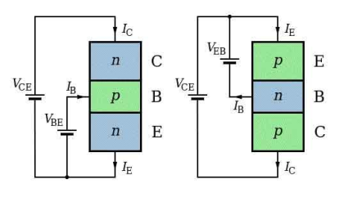

**Biasing Circuits of BJT:**

To make the Q point stable different biasing circuits are tried. The Q point is also called as operating bias point, is the point on the DC load line (a load line is the graph of output current vs. output voltage in any of the transistor configurations) which represents the DC current through the transistor and voltage across it when no ac signal is applied. The Q point represents the DC biasing condition. When the BJT is biased such that the Q point is halfway between cutoff and saturation than the BJT operates as a CLASS-A amplifier. The three circuits or biasing arrangements which are practically used are explained below.

**PROCEDURE:**

1. Measure all resistor values (R1, R2, RB and RC) from circuit in Fig. 1 using DMM. Record them.
2. Using the β determined for 2N3904 transistor in Part B, calculate the theoretical values of VB, VE, IE, IC, VC, VCE and IB for the network shown in Fig. 1. Record them in Table
3. Construct the network of Fig. 1 and measure VB, VE, VC and VCE. Record them in Table

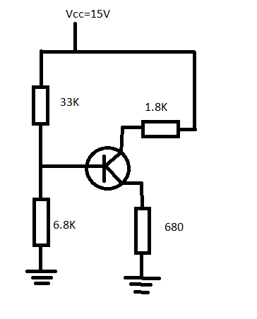

**RESULTS:**

Formulas:

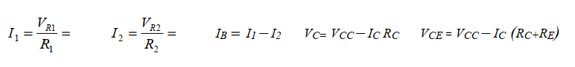

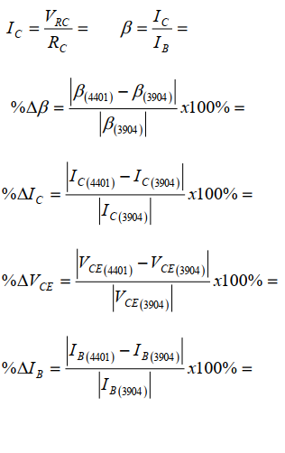

**LAB PRACTICAL:**

We calculate for two different transistors

**TABLE:**

|  |  |  |  |  |
| --- | --- | --- | --- | --- |
| **Trans. Type** | **VCE(V)** | **IC** | **IB** | β |
| 2N4401 | 174 mV | 4.44 A | 5 A | 0.888 |
| 2N2222 | 231 mV | 5.55 A | 5.65 A | 0.98 |

**%AGE ERROR:**

%error β **= 8.2%**

%error IB **= 11.5%**

%error IC **= 20%**

%error VCE **= 24 %**